1. Write a Python program to implement Simple Linear Regression

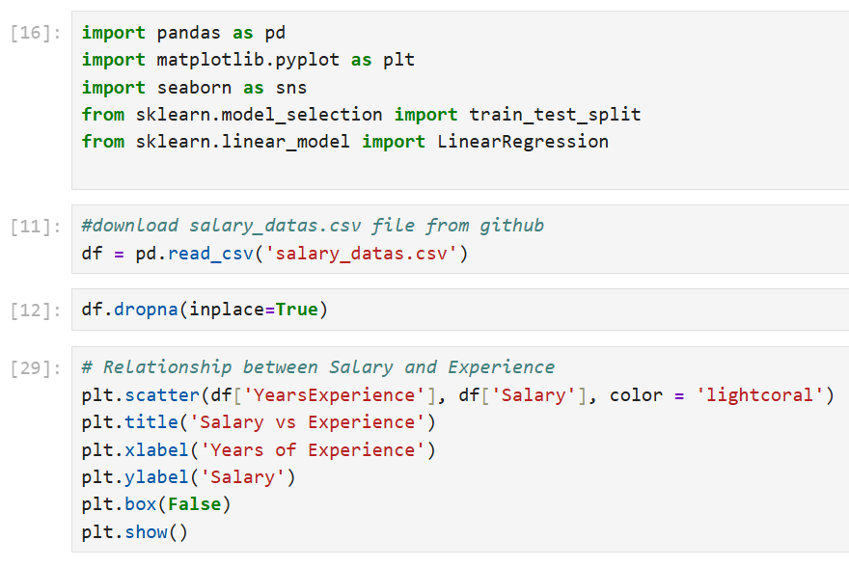

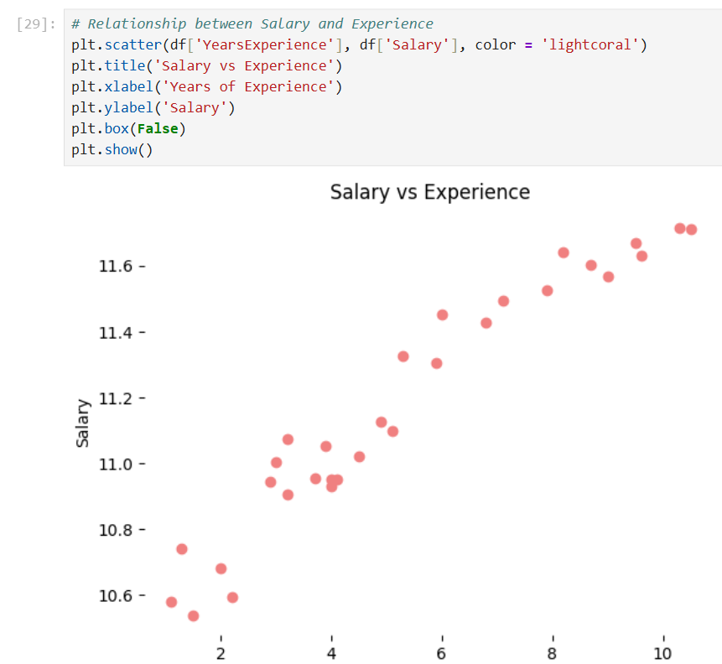

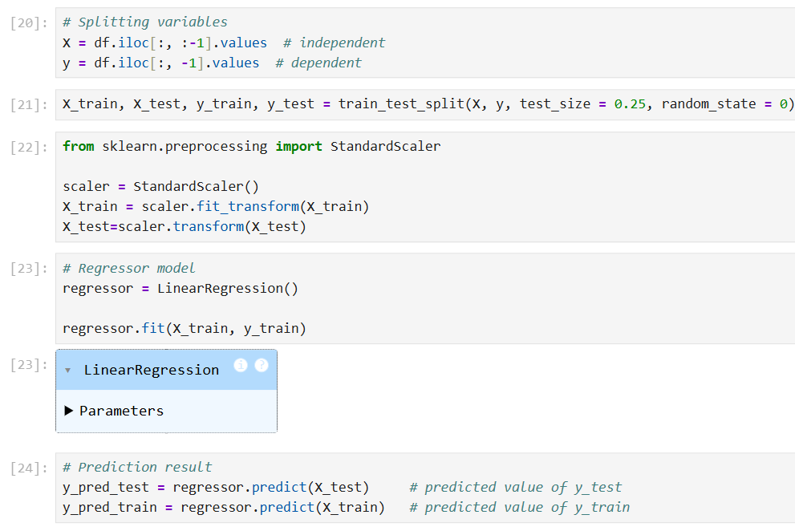

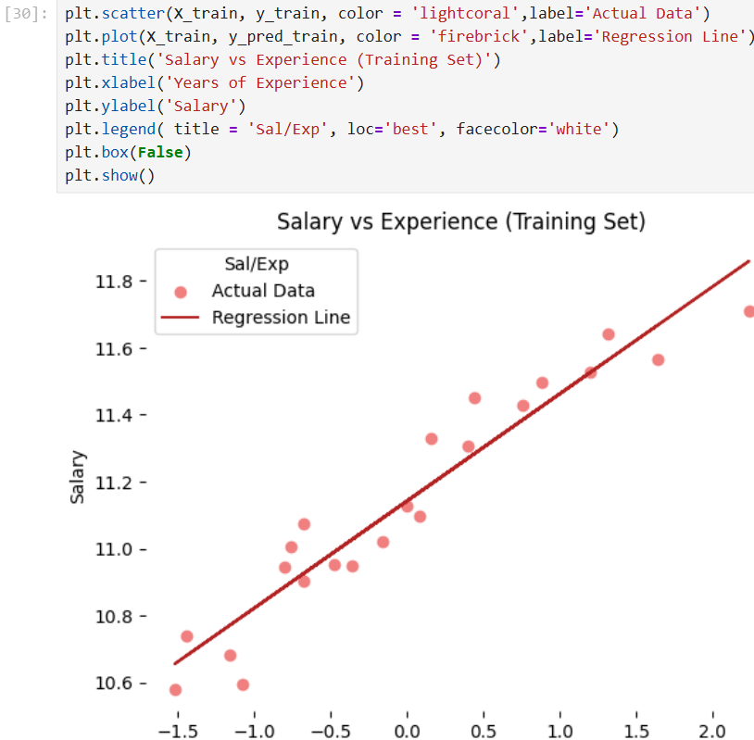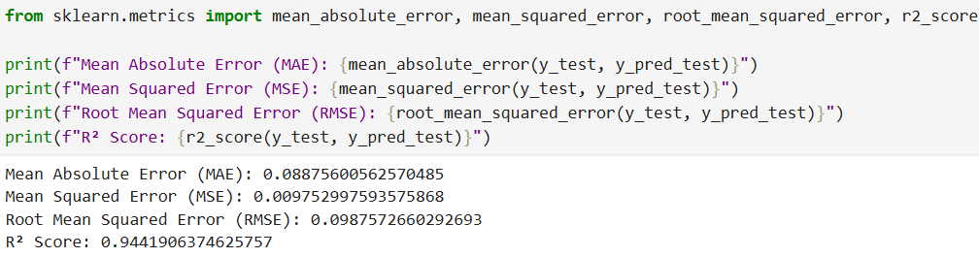

2. Write a program to demonstrate the use of various methods for data analysis and manipulation on a given dataset.

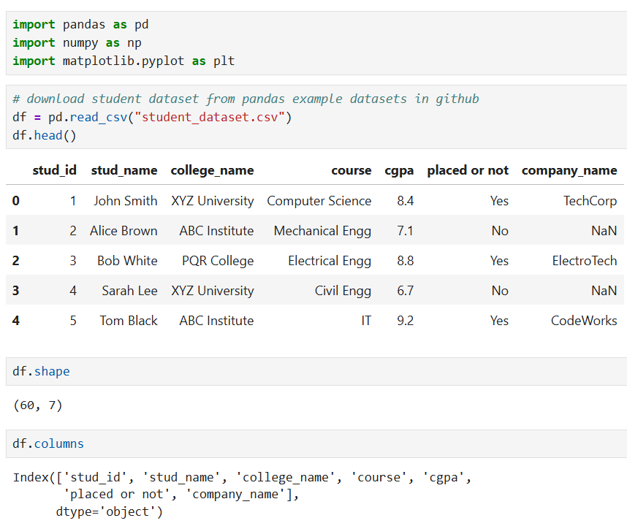 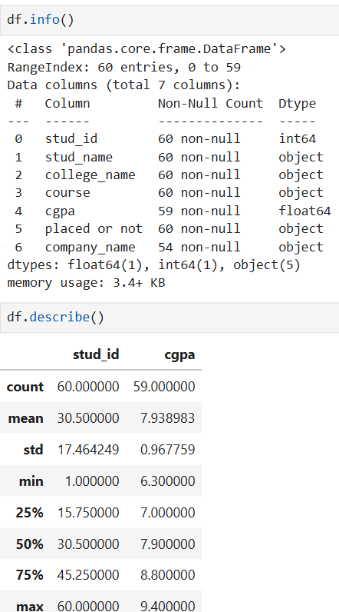

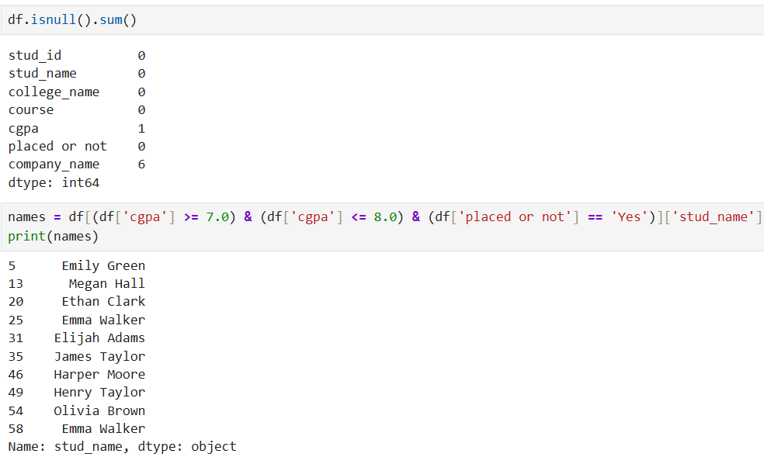

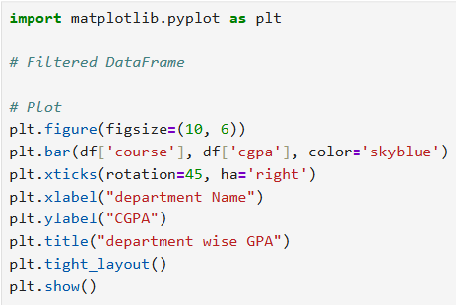 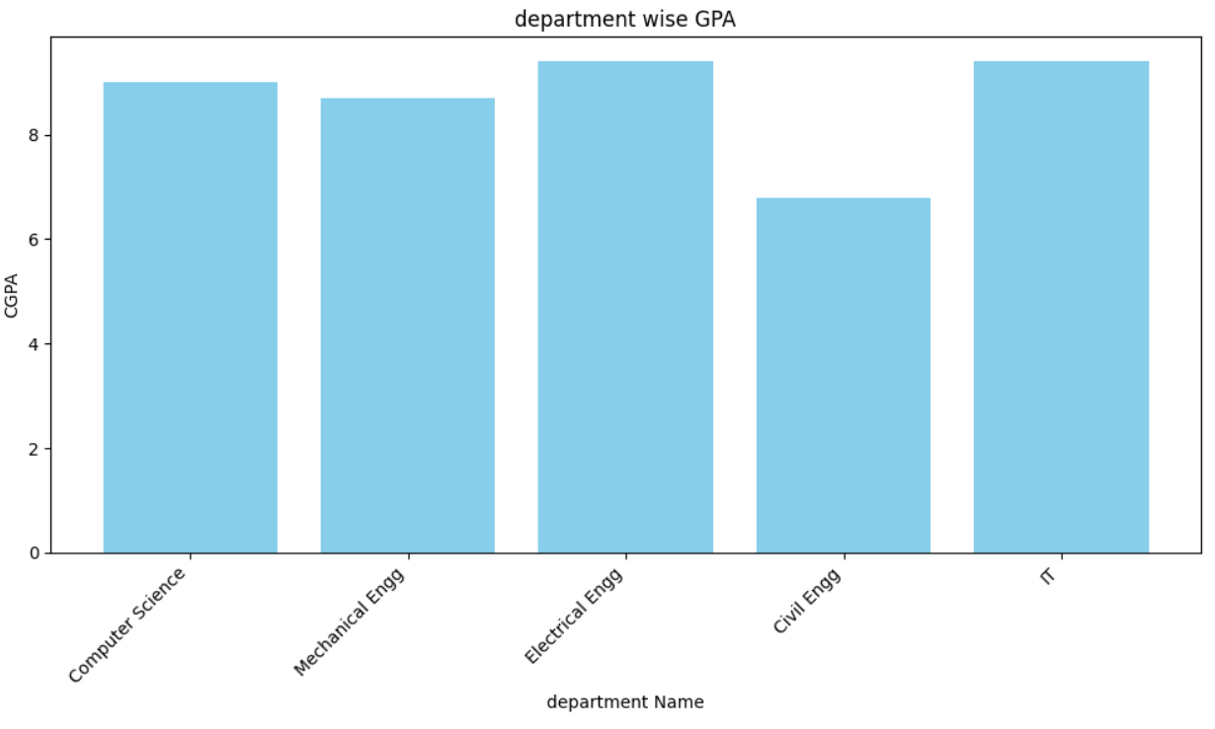

3. Develop a Binary classification model using Logistic Regression and apply it to classify a new instance.

4. Write a python program using Numpy to perform the following tasks

• Create a 1-D array and display the data type of the array.

• Create two 2D-arrays of the same shape and perform arithmetic operation on their elements.

• Concatenate the above 2D-arrays along rows or columns and display the result.

• Convert the concatenated array into a 1D-Array and display it.

• Create a 3x3 identity matrix and print its shape, number of dimensions and datatype.

5. Write a program to demonstrate Decision tree classifier. Use an appropriate dataset for building the model. 6. For the given dataset ‘cars.csv’ , perform the following

• Read the dataset

• Display last 5 rows

• Display first 5 rows

• Check for missing values

• Handle missing values

• Display the shape of dataset and statistical summary.

• Visualize the distribution of ‘Doors’ column using histogram.

7. Develop a model for multiclass classification using KNN classifier with K=5.Use an appropriate dataset for building the model.

8. Write a python program using Numpy to perform the following tasks

• Create a 2x4 array of zeros and 4x2 array of ones and display it.

• For each of the above arrays , print their shape, number of dimensions and datatype.

• Convert 4x2 array of ones into 1D- Array and display the result.

• Reshape it into a different valid shape.

• Create a 4D-Array and convert its element to float